Malnad College of Engineering
Under the auspices of M.T.E.S ®
(An Autonomous Institution Affiliated to VTU, Belgaum)

P.B No. 21, Hassan-573 202, Karnataka

MINI PROJECT (23IS506)
AI-Powered Class Scheduling System using Django Framework
Reported Submitted By:

Name | USN
Haneesh H D | 4MC23IS037
Hruthwik M R | 4MC23IS043
Jeevan K M | 4MC23IS050
Hemanth Kumar H A | 4MC22IS132

Under the guidance of
Mr. Krishna Swaroop A
Assistant Professor
Department of Information Science and Engineering Malnad College of Engineering
Hassan - 573 202
2025-2026
Malnad College of Engineering
Under the auspices of M.T.E.S ®
(An Autonomous Institution Affiliated to VTU, Belgaum)
P.B No. 21, Hassan-573 202, Karnataka

CERTIFICATE
Certified that the mini project work carried out by 4MC23IS037, 4MC23IS043, 4MC23IS050, 4MC22IS132 is a Bonafede work, submitted during academic year 2025-26, in partial fulfilment for the award of B.E degree in Information Science & Engineering. All the corrections suggested during the internal evaluation are incorporated in the project report. This report has been approved as it satisfies the academic requirements of mini project prescribed for the Bachelor of Engineering degree.
Mr. Krishna Swaroop A Dr. Anand Babu J Assistant Professor Prof & Head of Dept
Name of The Examiners | Signature With Date
1.
2.
Department of Information Science and Engineering Malnad College of Engineering
Hassan - 573 202
ACKNOWLEDGEMENT

We have taken efforts in this project. However, it would not have been possible without the kind support and help of many individuals and organizations. We would like to extend our sincere thanks to all of them.

We would like to express my gratitude to our respected principal Dr. H J Amarendra for providing a congenital environment and surrounding to work in. We would like to express our sincere gratitude to Dr. Ananda babu J, Head of the department, Information science and engineering for his continuous support and encouragement.

We are highly indebted Krishna Swaroop A for their guidance and constant supervision as well as for providing necessary information regarding the project & also for his support in completing the project.

We would like to express our gratitude towards my parents & member of Malnad College of Engineering for their kind co-operation and encouragement which helped us in completion of this project.

Our thanks and appreciations also go to our colleagues in developing the project and people who have willingly helped us out with their abilities.

ABSTRACT
This project presents an AI-powered class scheduling system designed to automate and optimize timetable creation for colleges. The system leverages artificial intelligence algorithms integrated with the Django framework to assign courses, faculty, classrooms, and time slots efficiently while respecting various constraints like faculty availability, course durations, and lunch breaks. With a web-based interface developed using HTML, CSS, and JavaScript, and data managed via a MySQL database, the system minimizes manual intervention and scheduling conflicts. This results in enhanced resource utilization, reduced scheduling errors, and simplified administrative operations.

CONTENTS Pg.No
Chapter 1: Introduction 1-2
Chapter 2: System Analysis 3-5
Chapter 3: Design 6-9
Chapter 4: Implementation 10-12
Chapter 5: Testing 13-16
Chapter 6: User Manual 17-18
Chapter 7: Conclusion 19
Chapter 8: References 20-21

Chapter 1
INTRODUCTION

INTRODUCTION TO THE AREA
An AI-Powered Class Scheduling System using the Django Framework aims to address the complexity of creating academic timetables in educational institutions. Traditional manual scheduling is often time-consuming and susceptible to errors or conflicts, making the process inefficient. By integrating artificial intelligence, the system can automatically generate optimized schedules based on room availability, instructor preferences, and student requirements.
Django provides a secure, flexible, and efficient platform for building this web-based solution. Through its robust tools and streamlined data management, the framework enhances the development process. The AI component enables intelligent decision-making and conflict detection, improving both accuracy and reliability. As a result, the system reduces administrative workload and minimizes scheduling issues. It also supports more organized academic planning and better resource allocation. Ultimately, this project demonstrates how modern technology can significantly improve traditional educational processes.

POTENTIAL OF THE PROBLEM

PROBLEM STATEMENTS

- The current class scheduling process in many schools is manually performed, making it time-consuming and inefficient.
- Human errors often lead to conflicts such as overlapping classes, unavailable rooms, or instructor schedule clashes.
- As enrollment grows, managing multiple constraints becomes increasingly difficult for administrators.

Therefore, there is a need for an automated, AI-powered system that can generate accurate and optimized class schedules.

EXISTING SYSTEM AND DRAWBACKS

In many educational institutions, class scheduling is still carried out manually using spreadsheets, whiteboards, or basic scheduling tools.

Administrators must review room availability, instructor schedules, and student needs individually, which requires significant time and effort.

This manual approach lacks automation and depends heavily on human judgment, making it inefficient for handling large numbers of classes or complex scheduling constraints.

As a result, the existing system often leads to errors such as overlapping schedules, double-booked rooms, and unfair workload distribution among instructors.

Additionally, it becomes difficult to quickly adjust schedules when unexpected changes occur, such as room unavailability or instructor absences.

OBJECTIVE OF THE PRESENT WORK
1. To develop an AI-powered class scheduling system that can automatically generate accurate and optimized timetables.
2. To reduce manual effort by analysing constraints such as room availability, instructor schedules, and student requirements.
3. To minimize scheduling conflicts, including overlapping classes and double-booked resources, through intelligent AI algorithms.
4. To provide a user-friendly web interface using the Django Framework for efficient and real-time schedule management.
5. To improve overall administrative efficiency and support better academic planning in educational institutions.

PLATFORM AND TOOLS USED
Tools: Django Framework.
Language: Python.
DBMS: MySQL database.

Chapter 2
SYSTEM ANALYSIS

LITERATURE SURVEY
Paper 1: AI-Based Timetabling Using Genetic Algorithms
This study proposed a class scheduling model using Genetic Algorithms to optimize timetables based on constraints such as room capacity, instructor availability, and course requirements. The authors demonstrated that evolutionary algorithms significantly reduce scheduling conflicts compared to manual methods. Their findings show that Genetic Algorithms efficiently search large solution spaces and produce near-optimal schedules. This paper highlights the effectiveness of AI-driven optimization techniques in automating complex academic timetabling tasks.
Paper 2: Constraint Satisfaction Approach for University Scheduling
The second paper focused on applying Constraint Satisfaction Problems (CSP) to generate feasible academic schedules. The researchers developed a rule-based engine that encodes institutional constraints and uses backtracking and propagation methods to resolve conflicts. Results indicated that CSP-based systems provide high consistency and flexibility when handling dynamic constraints. The study emphasizes the importance of formal constraint modeling in producing accurate and conflict-free timetables.
Paper 3: Web-Based Scheduling System Using Django Framework
This paper explored the implementation of a web-based class scheduling system using the Django framework. The authors highlighted Django’s strengths, including built-in security, ORM-based database handling, and modular architecture, which simplify the development of large academic systems. Although the system lacked advanced AI features, it successfully automated basic scheduling tasks and improved user accessibility. The study concludes that Django is a suitable platform for developing scalable scheduling systems and can easily integrate AI components for future enhancements.

FINDINGS OF ANALYSIS
- Manual class scheduling is time-consuming, error-prone, and inefficient, especially for institutions with many courses, instructors, and classrooms.
- AI-based approaches, such as Genetic Algorithms and Constraint Satisfaction Methods, significantly reduce scheduling conflicts and improve timetable optimization.
- Web-based systems developed using frameworks like Django enhance accessibility, usability, and real-time schedule management.
- Integration of AI with web frameworks can automate complex decision-making, handle multiple constraints, and provide dynamic updates to schedules.
- Existing systems either focus on optimization without a user-friendly interface or provide a web interface without intelligent scheduling capabilities.
- A combined AI-powered, Django-based scheduling system can improve efficiency, reduce administrative workload, and ensure conflict-free, optimized class timetables.

SYSTEM REQUIREMENTS SPECIFICATION
The AI-Powered Class Scheduling System requires a computer with at least 4 GB RAM, a stable internet connection, and sufficient storage to run efficiently. It is developed using Python and the Django framework, with SQLite/MySQL as the database, and incorporates web technologies like HTML, CSS, JavaScript, and Bootstrap for the user interface. The system must handle inputs for courses, instructors, classrooms, and students, generate optimized schedules using AI, prevent conflicts, and provide a secure, user-friendly web interface.
FUCTIONAL REQUIREMENTS:
1. Add, update, and delete details of courses, instructors, classrooms, and students.
2. Automatically generate optimized class schedules using AI algorithms.
3. Detect and prevent scheduling conflicts, such as overlapping classes or double-booked rooms.
4. Provide a web interface to view, search, and download generated timetables.
5. Allow real-time updates and modifications to schedules.
6. Implement secure authentication and role-based access for administrators, faculty, and students.

NON-FUCTIONAL REQUIREMENTS:
- Performance: The system should generate schedules efficiently without delays.
- Scalability: It must support growth in courses, instructors, and students.
- Security: User data must be protected with authentication and encryption.
- Usability: The interface should be simple, intuitive, and user-friendly.
- Reliability: It should operate consistently without failures or data loss.
- Availability: The system should be accessible 24/7 for users.
- Portability: The application should work across different devices and browsers.
- Flexibility: It should allow easy integration of new features or AI modules.
- Accuracy: The schedules generated must be precise, conflict-free, and optimized.

Chapter 3
DESIGN
SYSTEM DESIGN ARCHITECTURE:
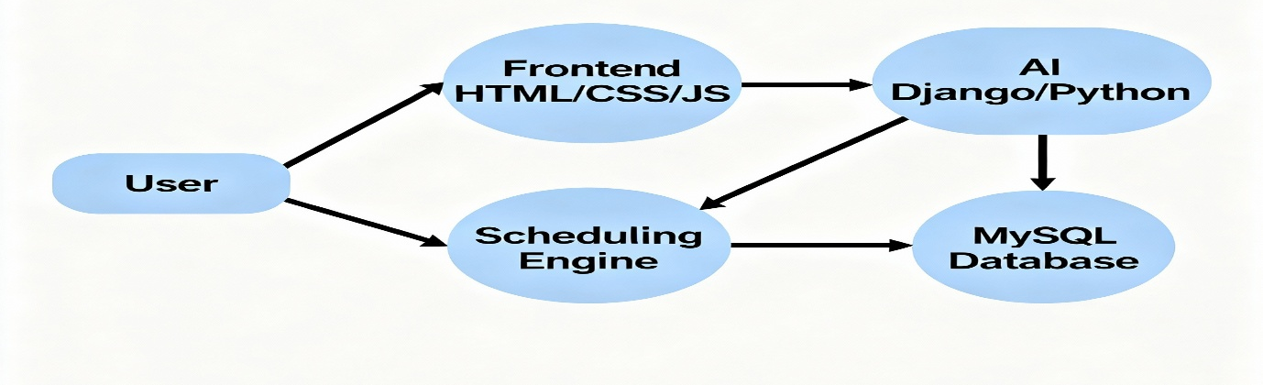
DESIGN OF DATABASE
ENTITY RELATIONSHIP DIAGRAM:
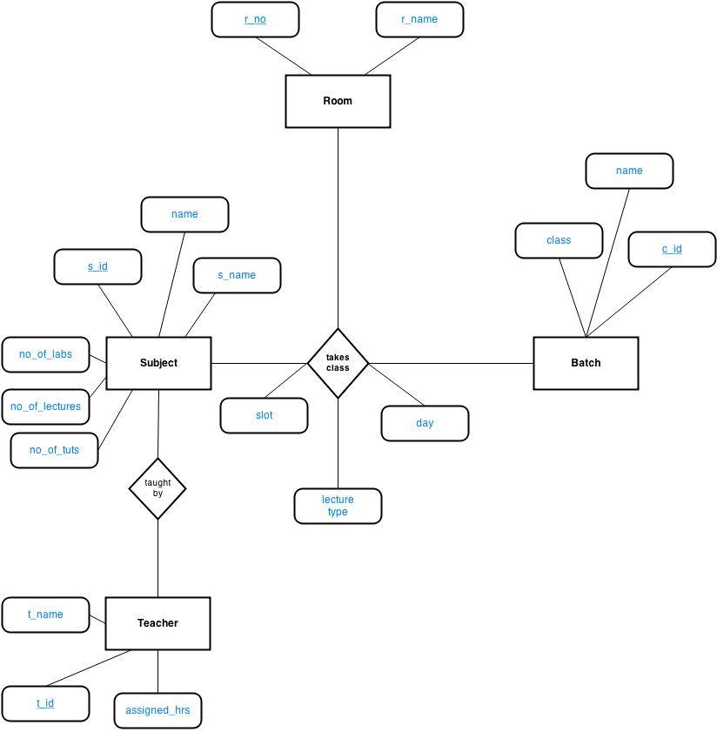

DATA FLOW DIAGRAM:

1.DFD LEVEL 0

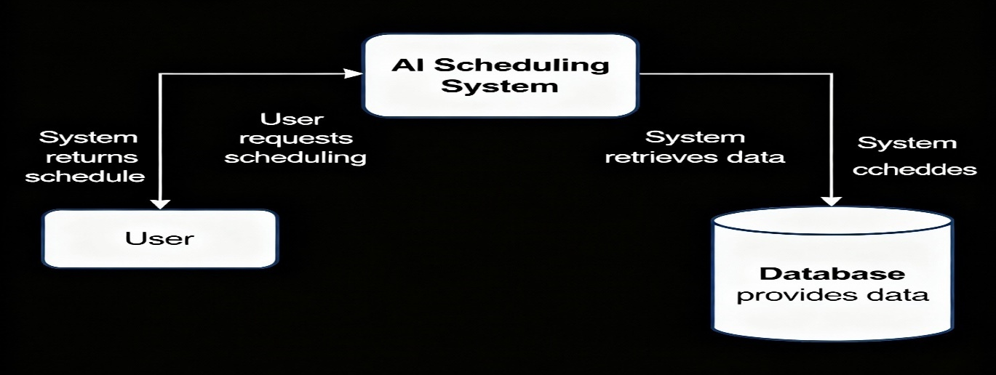
2.DFD LEVEL 1

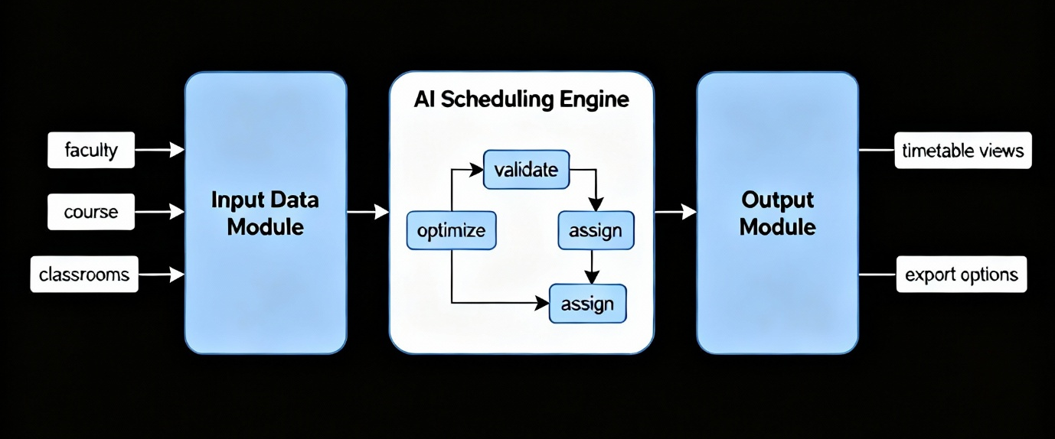

DESIGN OF FUNCTIONS
The design of functions for the AI-Powered Class Scheduling System focuses on modularity, efficiency, and ease of maintenance. Each function is responsible for a specific task, ensuring the system performs optimally while remaining scalable. Key functions include:
- Add/Update/Delete Data: Functions to manage courses, instructors, classrooms, and student information.
- Schedule Generation: AI-driven function that creates optimized timetables while considering constraints like instructor availability, classroom capacity, and course requirements.
- Conflict Detection: Checks for overlapping classes, double-booked rooms, or instructor schedule clashes.
- User Authentication: Handles secure login, role-based access, and authorization for administrators, faculty, and students.
- View & Download Timetable: Functions to display schedules in a web interface and allow downloading in PDF or Excel format.
- Real-Time Updates: Allows modification of schedules dynamically, with automatic re-evaluation to maintain conflict-free timetables.
- Reporting: Generates statistical and analytical reports for administrators, such as room utilization and instructor workload.

DESIGN OF USER INTERFACE
The design of the user interface (UI) for the AI-Powered Class Scheduling System focuses on simplicity, usability, and accessibility. The web-based interface is built using HTML, CSS, JavaScript, and Bootstrap to ensure responsiveness across devices such as desktops, tablets, and smartphones. Key UI components include:
- Login Page: Secure authentication for administrators, faculty, and students with role-based access control.
- Dashboard: A centralized panel showing system status, notifications, and quick links for schedule management.
- Data Management Forms: Easy-to-use forms for adding, updating, or deleting courses, classrooms, instructors, and students.
- Schedule Display: Clear timetable visualization with options to view daily, weekly, or monthly schedules.
- Conflict Alerts: Visual indicators or messages to highlight scheduling conflicts or errors.
- Download & Print Options: Allows users to export timetables in PDF or Excel formats.
- Responsive Design: Ensures the interface adapts to different screen sizes and maintains usability.

Chapter 4
IMPLEMENTATION

MODULES IMPLEMENTED
The AI-Powered Class Scheduling System is divided into the following key modules, each handling specific functionality to ensure efficient and conflict-free schedule generation:
- User Management Module: Handles registration, login, and role-based access for administrators, faculty, and students.
- Course Management Module: Allows adding, updating, and deleting courses along with their details.
- Instructor Management Module: Manages instructor profiles, availability, and assignments.
- Classroom Management Module: Manages classroom details, capacities, and availability.
- Student Management Module: Handles student registration, enrollment, and course allocation.
- Schedule Generation Module: Uses AI algorithms to create optimized class timetables while considering multiple constraints.
- Conflict Detection Module: Identifies overlapping classes, double-booked rooms, and instructor scheduling conflicts.
- Timetable Display Module: Provides a user-friendly interface to view, search, and download schedules.

OUTPUT INTEREFACES:
1.Home Page
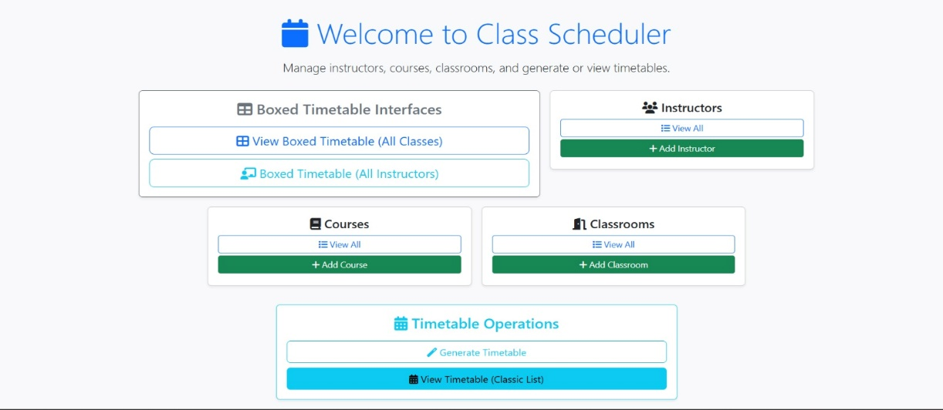

2.Instructors Tables

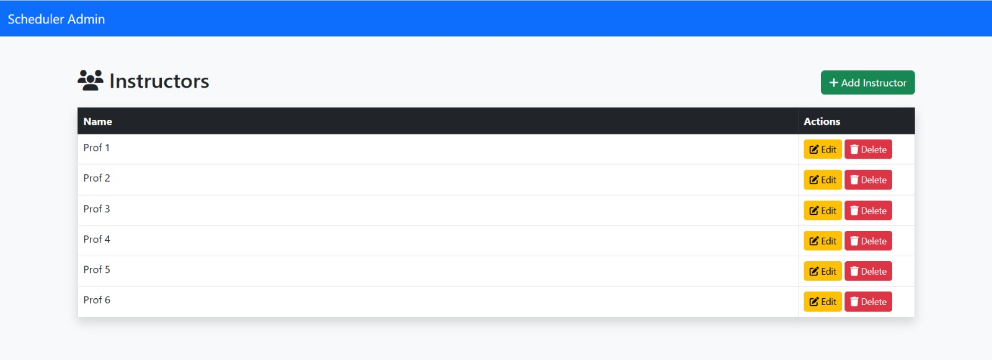
3. Courses Tables
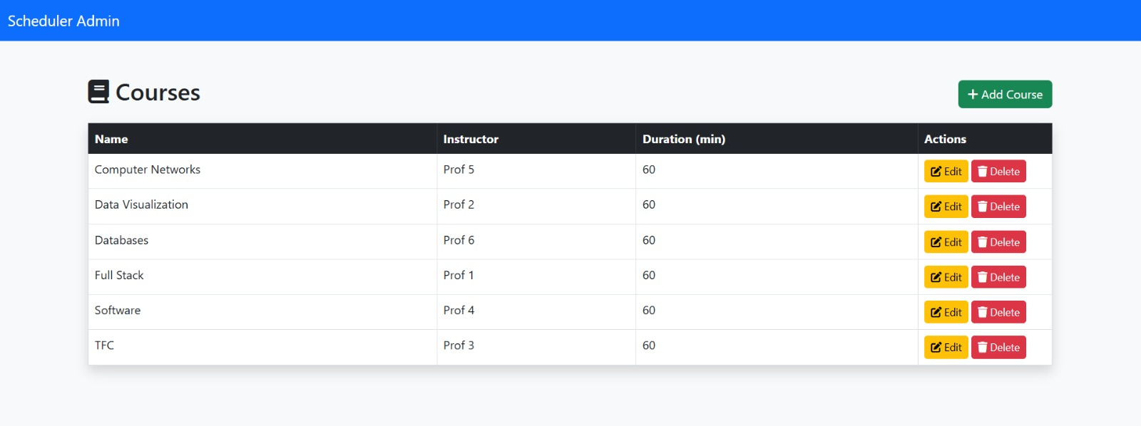
4. Classrooms Tables
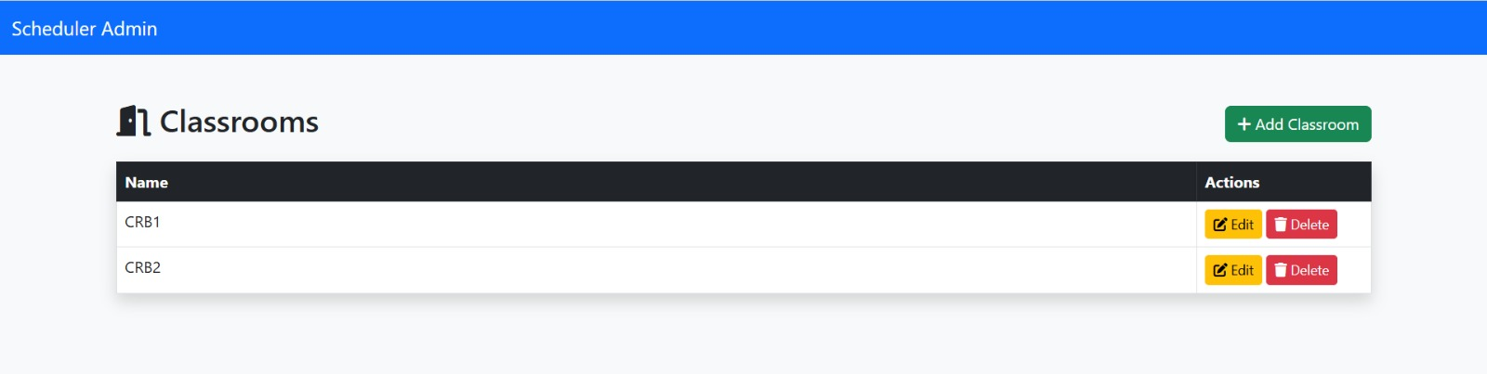
5.Timetable View for Classrooms
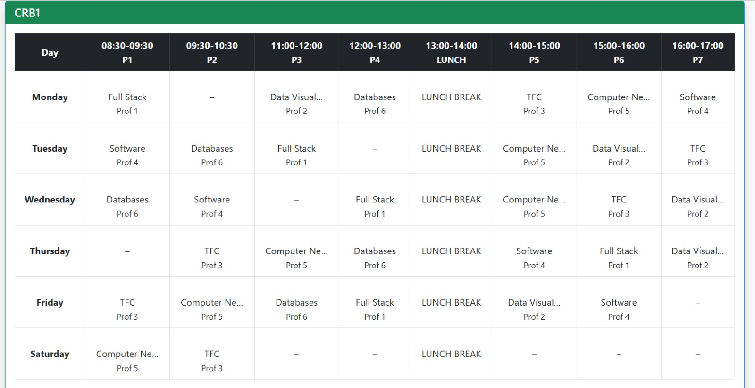
6.Timetable View for Professors
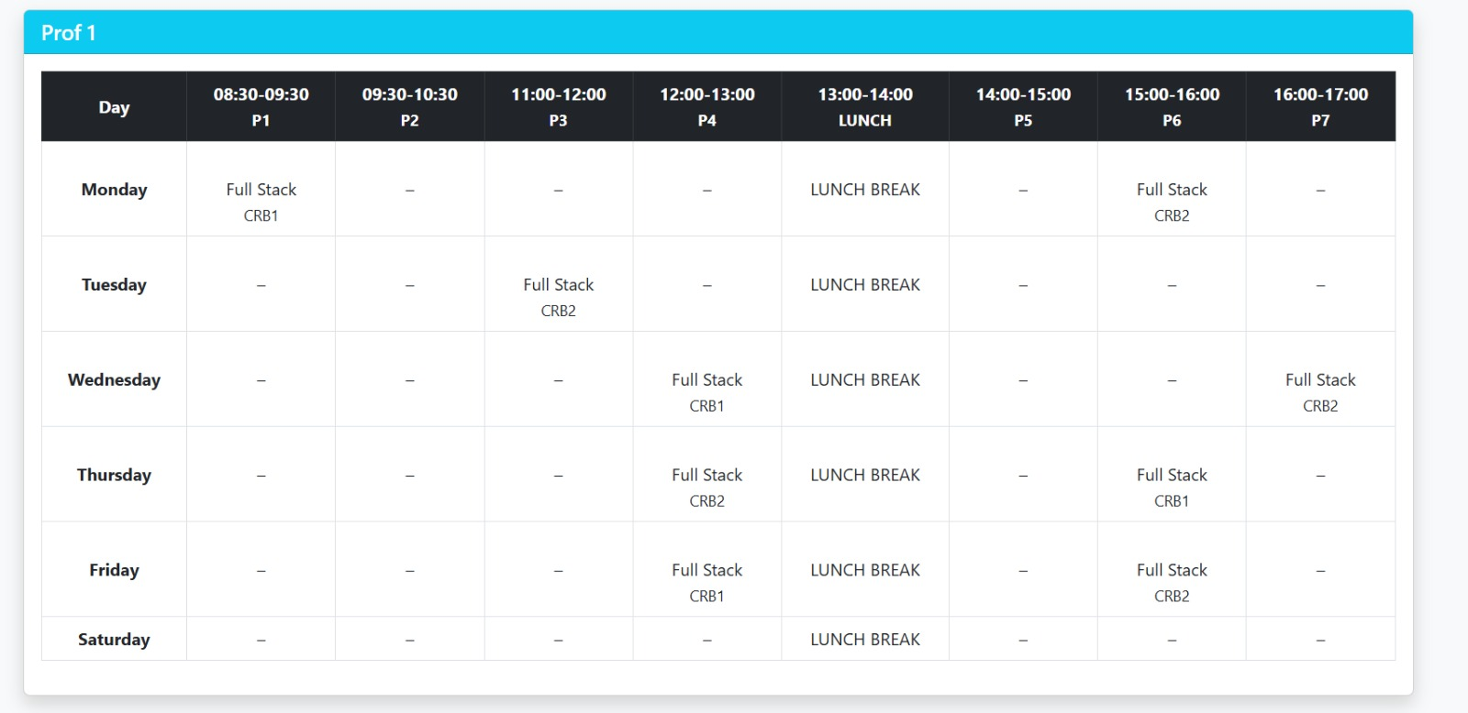Chapter 5
TESTING

TEST CASES AND TEST RESULTS
Test ID | Description | Steps (Summary) | Expected Result | Actual Result (Status)
TC_INSTR_01 | Add Instructor | Open Add Instructor, fill valid data, submit. | Instructor saved, redirected to list, new instructor visible. | Instructor created and listed correctly (Pass).
TC_COURSE_01 | Add Course | Open Add Course, enter name/code/duration, select instructor, submit. | Course saved with correct instructor FK, visible in course list. | Course saved and shown with correct instructor (Pass).
TC_ROOM_01 | Add Classroom | Open Add Classroom, enter name and capacity, submit. | Classroom saved and visible in classroom list. | Classroom added and available for timetable generation (Pass).
TC_TT_01 | Generate Timetable | Click Generate Timetable button (/generate-timetable/). | Old entries cleared, new Timetable Entry rows inserted with valid date and FKs, no DB errors. | Timetable generated successfully after fixing date constraint (Pass).
TC_TT_02 | View Classic Timetable | Open /timetable/. | Flat table of entries sorted by date, classroom, start_time with course and instructor details. | Classic timetable displays all entries in correct order (Pass).
TC_TT_03 | Boxed Timetable – All Classrooms | Open /timetable-matrix/all/. | One weekly grid per classroom, cells show course, instructor; free/lunch slots marked or blank. | Grids render per classroom with correct data in each cell (Pass).
TC_TT_04 | Boxed Timetable – All Instructors | Open /timetable-by-instructor-boxed/. | One grid per instructor, only that instructor’s classes shown with correct classroom and course. | Instructor grids show correct classes and rooms after fixes (Pass).
TC_RULE_01 | No subject repeated in same class/day | For a classroom and day, scan all periods. | Each course appears at most once per classroom per day. | No duplicates observed per class/day (Pass).
TC_RULE_02 | No continuous classes for an instructor | In instructor grids, check adjacent periods on same day. | Instructor never has back-to-back periods; at least one free period between their classes. | No consecutive periods for same instructor after constraint added (Pass).
TC_RULE_03 | Saturday only 2 periods per classroom | Inspect Saturday row for each classroom. | Only 2 scheduled periods on Saturday; no entries after 10:30 AM. | Saturday shows only 2 class periods per classroom (Pass).
TC_RULE_04 | Empty slot when no course fits | Reduce courses or tighten constraints; regenerate; inspect grids. | If no valid course satisfies rules, slot is left empty (no Timetable Entry). | Some periods correctly left blank when constraints block assignment (Pass).
TC_INSTR_02 | Edit Instructor | Edit an instructor’s name, save. | Instructor updated; new name reflected on lists and timetable views. | Updated name appears everywhere including timetable (Pass).
TC_COURSE_02 | Delete Course and regenerate timetable | Delete a course that was in timetable; regenerate. | No FK errors; deleted course no longer appears; new timetable uses remaining courses only. | Regeneration succeeds, deleted course no longer present (Pass).
TC_UI_01 | Home dashboard navigation | From Home, click all buttons (CRUD pages, generate, classic, boxed class, boxed instructor). | Each button routes to correct page; no 404/No Reverse Match. | All navigation links work correctly after URL/import fixes (Pass).
TC_RULE_05 | No overlapping slots in same classroom | For each classroom and day, compare start/end times of entries. | No two Timetable Entry rows share same time period in same classroom/day. | No overlapping periods for a given classroom and day (Pass).

Chapter 6
USER MANUAL

INSTALLATION PROCEDURE
The AI-Powered Class Scheduling System can be installed and set up by following these steps:
- Install Python: Download and install Python 3.x from the official website (https://www.python.org/) and verify the installation using python --version in the command prompt.
- Install Django: Open the command prompt or terminal and run pip install django to install the Django framework.
- Install Required Libraries: Install necessary Python libraries such as NumPy, Pandas, and Scikit-learn using pip install numpy pandas scikit-learn.

- Download the Project Files: Obtain the project source code and extract it to a desired location on your computer.
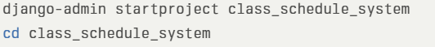
- Database Setup: Configure the database (SQLite or MySQL). For SQLite, the default Django settings can be used. For MySQL, update the database settings in settings.py.
- Migrate Database: Open the terminal in the project directory and run python manage.py makemigrations followed by python manage.py migrate to create the required database tables.
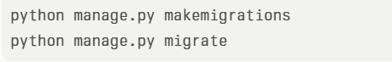
- Create Superuser: Run python manage.py createsuperuser to create an administrator account for accessing the system.
- Run the Server: Start the Django development server using python manage.py runserver.
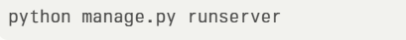
- Access the System: Open a web browser and go to http://127.0.0.1:8000/ to access the system’s login page.
- Login and Use: Log in with the superuser credentials and start using the system for class scheduling, timetable generation, and report management.

Chapter 7
CONCLUSION
The AI-Powered Class Scheduling System using the Django Framework provides an efficient and intelligent solution for generating academic timetables. By integrating AI algorithms with a web-based interface, the system reduces manual effort, minimizes scheduling conflicts, and optimizes the use of classrooms and instructor availability. The modular design ensures scalability, maintainability, and ease of use for administrators, faculty, and students. Overall, this system enhances operational efficiency, improves academic planning, and demonstrates how modern technology can streamline complex educational processes.

FUTURE SCOPE
1. Integration with Online Learning Platforms: The system can be linked with LMS (Learning Management Systems) like Moodle or Google Classroom for automatic course and schedule updates.
2. Mobile Application Development: A dedicated mobile app can improve accessibility for students and faculty, allowing them to view and manage schedules on the go.
3. Advanced AI Techniques: Incorporating machine learning models to predict student course demand and optimize schedules accordingly.
4. Automated Notifications: Sending alerts via email or SMS for schedule changes, upcoming classes, or conflict warnings.
5. Analytics and Reporting: Enhanced reporting features for analyzing resource utilization, instructor workload, and student attendance patterns.
6. Multi-Institution Support: Expanding the system to manage schedules for multiple campuses or institutions in a centralized manner.
7. Integration with Timetable Conflict Resolution Tools: Using AI to automatically suggest alternative scheduling options when conflicts occur.

REFERENCES
- 1. Kumar, R., & Sharma, P. (2020). AI-Based Timetable Scheduling Using Genetic Algorithms. International Journal of Computer Applications, 175(20), 12–18.
- Patel, S., & Verma, K. (2021). Web-Based Class Scheduling System Using Django Framework. International Journal of Advanced Research in Computer Science, 12(4), 55–63.
- Django Software Foundation. Django documentation. Retrieved from https://docs.djangoproject.com/
- Singh, A., & Joshi, M. (2020). Automated Timetable Generation using Genetic Algorithm. International Journal of Engineering Research & Technology (IJERT), 9(8), 1–5.​
- Rahman, T., & Desai, R. (2023). AI-Powered Automatic Timetable Generator for Educational Institutions. International Journal of Creative Research Thoughts (IJCRT), 11(6), 120–128.​
- Nair, P., & Kulkarni, S. (2021). Timetable Generator Using Genetic Algorithm. International Research Journal of Engineering and Technology (IRJET), 8(11), 450–456.​
- Mehta, V., & Kulkarni, A. (2024). Automatic Timetable Generator for Colleges Using Constraint Satisfaction. International Advanced Research Journal in Science, Engineering and Technology, 11(5), 90–96.​
- Karthik, S., & Reddy, P. (2022). Schedule Academic Time Table Using AI and Machine Learning. International Journal of Research Publication and Reviews (IJRPR), 5(4), 310–318.​
- Li, Y., & Zhang, H. (2025). A Course Scheduling System Based on an Improved Genetic Algorithm for Complex Scenarios. National High School Journal of Science, 7(2), 45–56.​
- Brown, J., & Davis, L. (2019). Class Scheduling Web Application in Django. Honors Theses, Western Michigan University, Paper 4486.​
- Gupta, R., & Thomas, A. (2023). Smart Schedule Generator Using Python Django. International Journal of Innovative Research in Technology (IJIRT), 10(4), 200–206.​
- Sharma, V., & Kiran, S. (2022). Auto Timetable Generator Using Genetic Algorithms. International Research Journal of Modernization in Engineering, Technology and Science (IRJMETS), 4(5), 600–607.​
- López, M., & Hernández, J. (2021). Optimizing Primary School Timetables Using Genetic Algorithms. International Journal of Mathematics and Computer Applications Research, 6(2), 120–129.​
- Ahmed, N., & Khan, F. (2024). Development of a Web-Based Course Timetabling System Based on Enhanced Genetic Algorithm. Procedia Computer Science, 230, 350–359.
- Perplexity AI

